15th December 2025

Dear Parent/Carer

As the end of the Half Term 2 approaches, I wanted to take this opportunity to thank you for your support since September. Across the academy our students have enjoyed a hugely positive and productive term, showcasing their talents on a variety of platforms and engaging with a multitude of visitors to the Academy.

As eluded to in the most recent Principal’s Update, we will have a slightly earlier finish than usual on Friday 19th December. Details of this as well as arrangements for Christmas Lunch can be found below:

Wednesday 17th December
On this day Christmas dinner will be served in the school canteen. These meals have already been ordered and paid for. This year there will be Halal, turkey and vegetarian options with desert and a drink at lunchtime, alongside some of the usual alternatives available at breaktime.

Friday 19th December – Last day for all students
Lessons will continue as normal until 12:20, students will then move to their form groups with school finishing at an earlier time of 12:45pm. Please make sure collection times for any taxis and vans are amended accordingly.

School will re-open to students on Tuesday 6th January 2026.

I would like to wish you all a restful, safe and festive break.

Yours faithfully

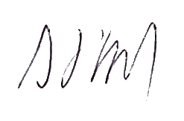

S Doyle
Principal

