17th July 2026

Dear Parent/Guardian,

I am writing to confirm arrangements for the end of this term and the start of next term (September 2026). School breaks up on Friday 24th July 2025, and students will be finishing at 12:30pm. They will be expected to leave the premises in the manner that they do on regular school days, and transport should be altered accordingly.

There are still several items in lost property. If you are missing anything, can you ask your son/daughter to check lost property as we can only hold items for 3 months before they are donated to charity. If you have any uniform (blazer, tie or PE tops) which you no longer require or students have grown out of, could students please bring them into school as they will be washed and used as spares. There is a blue container by reception where they can be dropped.

To enable us to complete induction as students return, there will be a staggered start to the term.

Students first day in school is indicated below:

Year 7,11,12 and 13 Friday 4th September 2026 8:40am
Years 8,9 and 10 Monday 7th September 2026 8:40am

Students will enter through the same entrance they have used this term with new Year 7s using the entrance by the Assembly Hall.

On behalf of all the staff at the academy, I thank you for your continued support in helping our children grow and flourish. We’ve enjoyed another really successful year moving our priorities forward and improving the overall provision across the academy. I hope our students who are awaiting examination results in the summer are equally as successful in August – there will be a separate communication about arrangement for results days.

I wish you a relaxing summer break and look forward to re-connecting in September.

Yours faithfully,
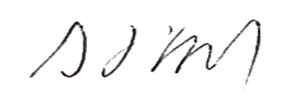

Mr S Doyle

